WITH job_title_salary AS (

-- Average salaries by job title

SELECT

'Job Title' AS category,

title AS subcategory,

TO_CHAR(AVG(salary), 'FM$999,999.00') AS average_salary,

NULL::TEXT AS min_salary,

NULL::TEXT AS max_salary,

COUNT(*) AS job_count

FROM joblistings

GROUP BY title

LIMIT 10

),

location_salary AS (

-- Average salary by location

SELECT

'Location' AS category,

location AS subcategory,

TO_CHAR(AVG(salary), 'FM$999,999.00') AS average_salary,

TO_CHAR(MIN(salary), 'FM$999,999.00') AS min_salary,

TO_CHAR(MAX(salary), 'FM$999,999.00') AS max_salary,

COUNT(*) AS job_count

FROM joblistings

WHERE title ILIKE '%data%'

GROUP BY location

),

remote_company_salary AS (

-- Companies with highest average salaries for remote jobs

SELECT

'Remote Jobs by Company' AS category,

company AS subcategory,

TO_CHAR(AVG(salary), 'FM$999,999.00') AS average_salary,

NULL::TEXT AS min_salary,

NULL::TEXT AS max_salary,

COUNT(*) AS job_count

FROM joblistings

WHERE job_description ILIKE '%remote%'

GROUP BY company

LIMIT 10

),

job_type_salary AS (

-- Salary by type of positions using job descriptions

SELECT

'Job Type' AS category,

CASE

WHEN job_description ILIKE '%full-time%' THEN 'Full-time'

WHEN job_description ILIKE '%part-time%' THEN 'Part-time'

ELSE 'Other'

END AS subcategory,

TO_CHAR(AVG(salary), 'FM$999,999.00') AS average_salary,

NULL::TEXT AS min_salary,

NULL::TEXT AS max_salary,

COUNT(*) AS job_count

FROM joblistings

WHERE job_description ILIKE '%full-time%' OR job_description ILIKE '%part-time%'

GROUP BY subcategory

),

position_type_salary AS (

-- Salary ranges by type of positions

SELECT

'Position Type' AS category,

type_of_positions AS subcategory,

TO_CHAR(AVG(salary), 'FM$999,999.00') AS average_salary,

TO_CHAR(MIN(salary), 'FM$999,999.00') AS min_salary,

TO_CHAR(MAX(salary), 'FM$999,999.00') AS max_salary,

COUNT(*) AS job_count

FROM joblistings

GROUP BY type_of_positions

)

-- Combine all CTEs into one result set

SELECT * FROM job_title_salary

UNION ALL

SELECT * FROM location_salary

UNION ALL

SELECT * FROM remote_company_salary

UNION ALL

SELECT * FROM job_type_salary

UNION ALL

SELECT * FROM position_type_salary

ORDER BY category, average_salary DESC;

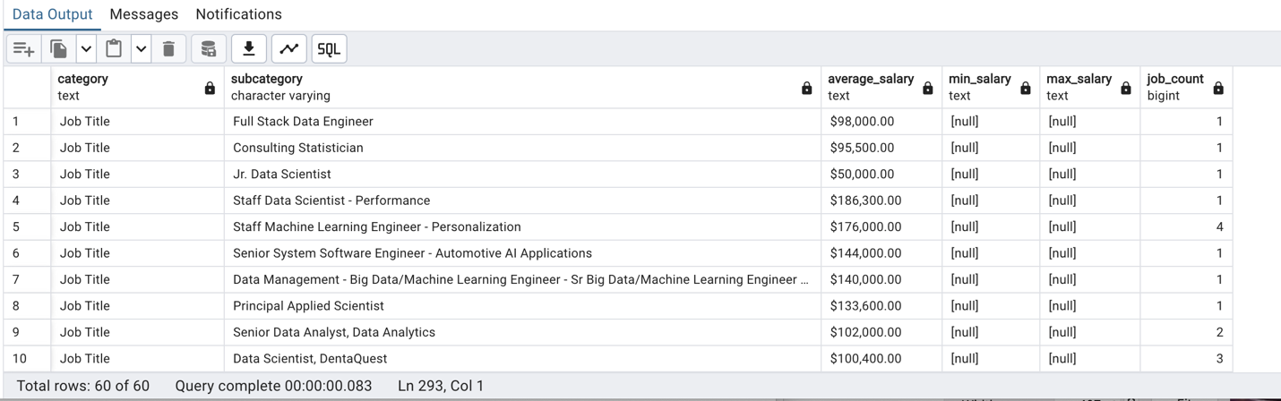

WITH salary_stats AS (

SELECT

type_of_positions AS category,

TO_CHAR(MIN(salary), 'FM$999,999.00') AS min_salary,

TO_CHAR(MAX(salary), 'FM$999,999.00') AS max_salary,

TO_CHAR(AVG(salary), 'FM$999,999.00') AS average_salary

FROM joblistings

GROUP BY type_of_positions

UNION ALL

SELECT

location,

TO_CHAR(MIN(salary), 'FM$999,999.00') AS min_salary,

TO_CHAR(MAX(salary), 'FM$999,999.00') AS max_salary,

TO_CHAR(AVG(salary), 'FM$999,999.00') AS average_salary

FROM joblistings

WHERE title ILIKE '%data%'

GROUP BY location

UNION ALL

SELECT

company,

NULL AS min_salary,

NULL AS max_salary,

TO_CHAR(AVG(salary), 'FM$999,999.00') AS average_salary

FROM joblistings

WHERE job_description ILIKE '%remote%'

GROUP BY company

UNION ALL

SELECT

CASE

WHEN job_description ILIKE '%full-time%' THEN 'Full-time'

WHEN job_description ILIKE '%part-time%' THEN 'Part-time'

ELSE 'Other'

END AS category,

NULL AS min_salary,

NULL AS max_salary,

TO_CHAR(AVG(salary), 'FM$999,999.00') AS average_salary

FROM joblistings

WHERE job_description ILIKE '%full-time%' OR job_description ILIKE '%part-time%'

GROUP BY category

)

SELECT * FROM salary_stats;

